**Start of development of the project** -  **the Idea**

Creating the idea for the project there and determining the best one to do picking from a mind map, having games that are all card games based on numbers.

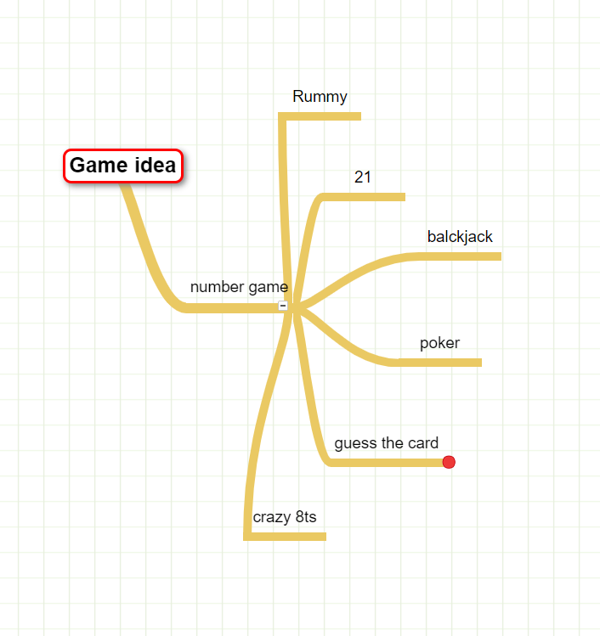

**Final decision -**

The Game similar to 21 or black jack being able to restart the game for the player.

**Crating a plan for the game - list of games basic functions and what are need for the game to function**

Large list on what needs to be done for the project and the final decision on the final game concept.

* Game must have an introduction to the player gathering player info.
* Give the rules of the game.
* The player must be able to get 2 random values.
* Player can get additional lvalues.
* If the player is over the value of 21 then the player loses.
* Player will face a dealer who also gets card values in the same way.
* Player can restart the game.

**Start of coding - creating the title screen to the game**

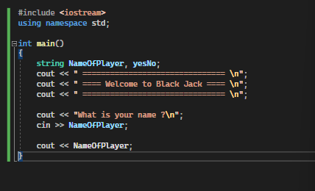

Start of development having the title screen made and getting the input of the players name and testing the function of the question.

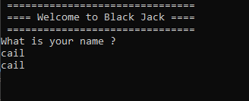

**Random number generator for the numbers**

Creating a Random number between 1-12 but doesn't work always gives the same values when doing the testing which is 6,11 but opting to change to 11.

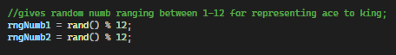

Solution was to add a using a solution by bitgree explaining how the rand functions and operates and giving examples like the one below.

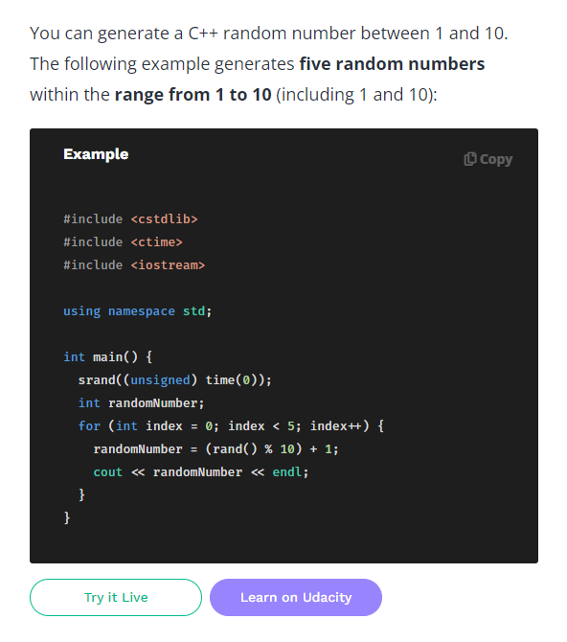

Random number gen by BitDegree (BitDegree)

Solution to the issue was using this below and having to set time to 0 for the program to function.



**Issues with the 21 calculating the values**

Calculating player number of cards and testing if it works conclusion is that ir dosnt work repeating the same thing over and over not stopping the program when “n” is imputed.

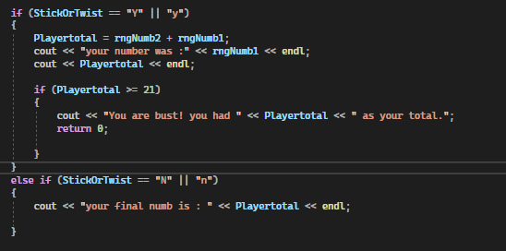

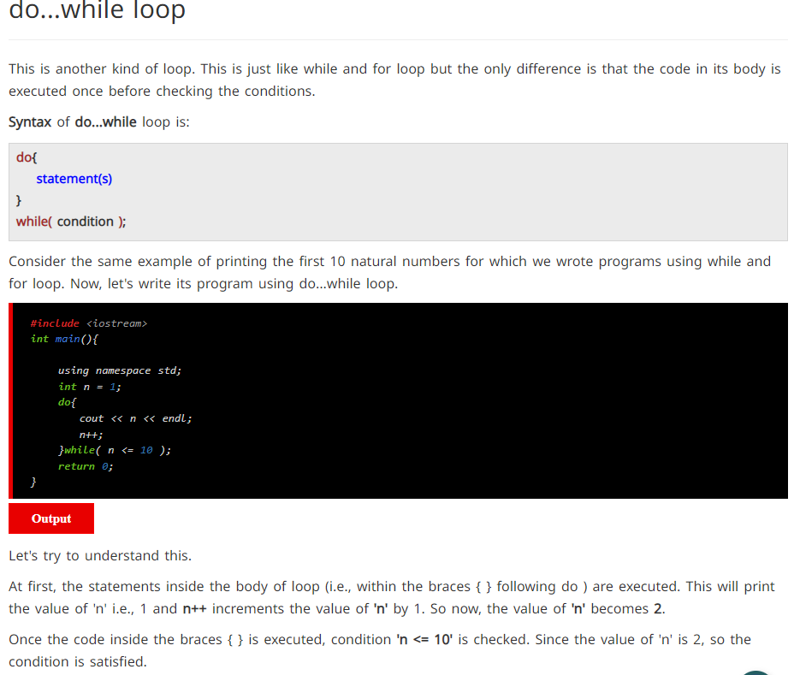

Loops document by CodesDope. (CodesDope)

The solution above was to a do while loop allowing me to get the player to get several input in 1 loop it showed me the basics of how to create the loop but [Buckys C++ Programming Tutorials - 24 - do while Loops](https://youtu.be/yRdPe2acogw)(YouTube, “Buckys C++ Programming Tutorials - 24 - Do While Loops”) showed and explaining the practical applications do i created in the code below, but there were issues regarding infinite looping but it was fixed with a “break”.

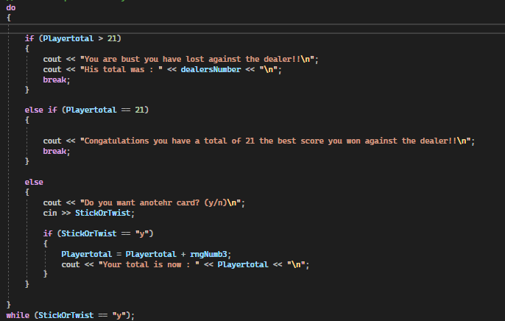

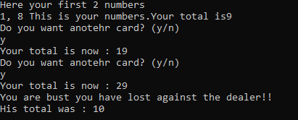

**Tests performed so far**

| **Test name** | **What should happen** | **What did happen** | **Fix or didn't need fixing(Worked)** |
| --- | --- | --- | --- |
| Title screen black jack appears | Title screen black jack appears showing the title screen on the page | Displayed the title | Worked |
| Able to print the players name and take the players input | take the players input and display it on screen in a later sentence | Displays the name inputted | Worked |
| Player can get 2 numbers of random value between 1-11 | Player get 2 values between 1-11 and these will be used in tadome for calculation further on in the program | No numbers were not random and displayed 5 and 9 each time | By putting srand(time(0));  At the top of the programm it allowed it to work |
| Dealers numbers were random and gave a value of 21 or under | Dealers numbers would get a value no fewer than 11 but no higher than 21 | Dealer was able to go over the value of 21 and therefor making it impossible to win | Set 1 of the dealers numbers to const to be 10 and the generator to give a random value between 1-11 making the max 21 |
| Function displays the rules | Function displays the rules to the player on screen | The function displayed the rules to the player | Worked |
| Player gets random number for the next number | Player will get a random number for the next number and will move on to be calculated | Players number is random | worked |
| Player is able to get numbers and finish if they wish to keep their number | Player is able to get 3 random numbers and finish if they wish with their number to try beat the dealer | Player is able to get 3 or more random numbers but getting more numbers would result in the same numbers | worked |

Starting on testing some of the features of the game and getting the game functional without crashing theres were some of the findings for today.

**Restarting the program over and over**

Restarts the program using a nested do while loop as the same as the 21 calculating to restart the program because the while loop wouldn't repeat on the program so I opted for a solution around it.

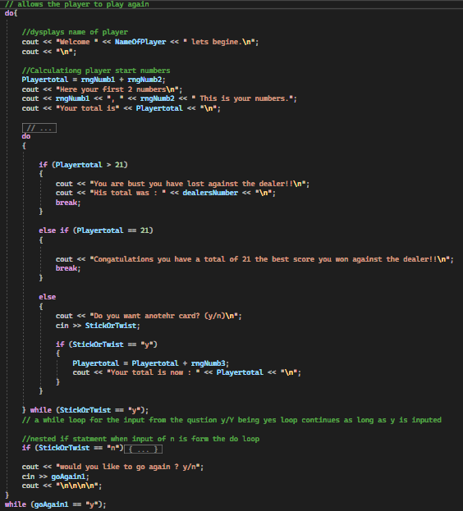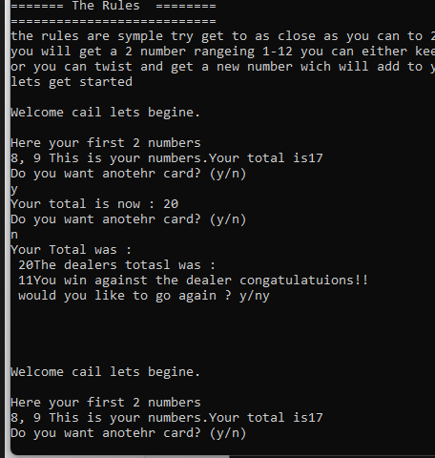

( How the program was in the end of testing )

**Issue with numbers not being random**

Issues with the numbers not being random throughout the program so the solution was very unclear so i watch youtube videos on making to program rng through a function using youtube videos i found this one “<https://youtu.be/V9zuox47zr0>” explaining on making a function able to do this.

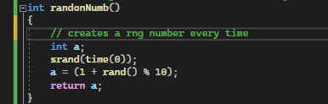

Allowing me to send a random number over to the main program that is truly random.

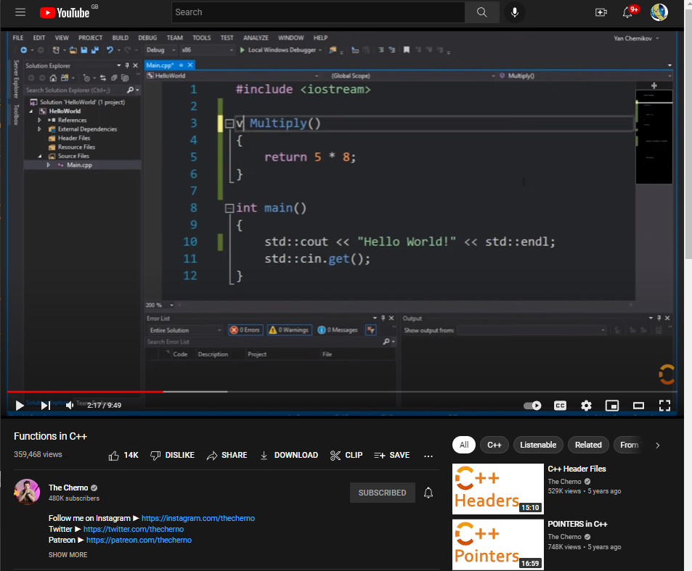

Image from the youtube video. (YouTube, “Functions in C++”)

**Final testing sheet**

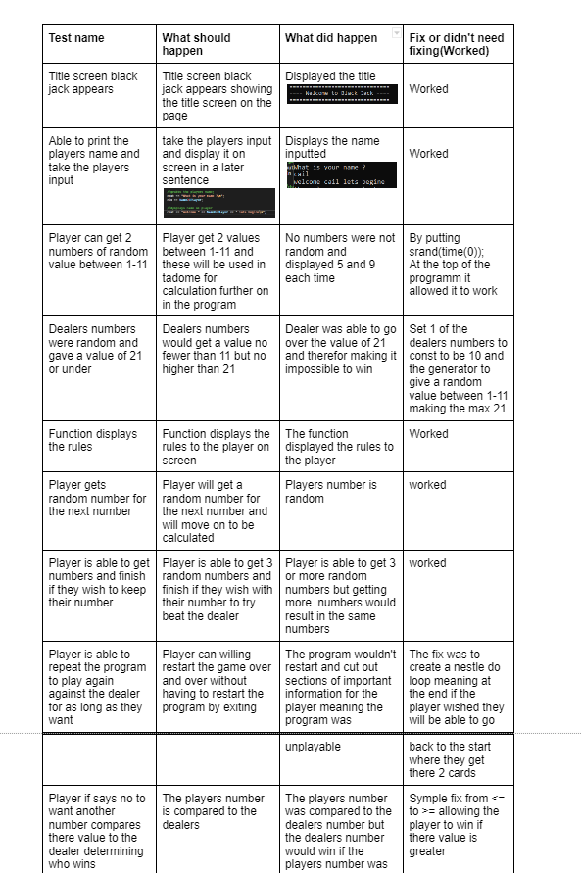

(Only some are shown)

All the tests i have ran up to this point ready for submission and present the final product

**Presentation of the final product**

**Youtube link -** [**https://youtu.be/lnesmF_wMCo**](https://youtu.be/lnesmF_wMCo)

**Reference list**

BitDegree,“Guide on a Random Number Generator C++: The Use of C++ Srand.” *Www.bitdegree.org*, www.bitdegree.org/learn/random-number-generator-cpp. Accessed 23 Aug. 2022.

CodesDope, “C++ Loops: Learn While, For, Do-While, Nested and Infinite Loops.” *CodesDope*, www.codesdope.com/cpp-loops/. Accessed 23 Aug. 2022.

w3schools, “C++ Function Parameters.” *Www.w3schools.com*, www.w3schools.com/cpp/cpp_function_param.asp. Accessed 23 Aug. 2022.

YouTube, “Buckys C++ Programming Tutorials - 24 - Do While Loops.” *Www.youtube.com*, youtu.be/yRdPe2acogw. Accessed 24 Aug. 2022.

Youtube, “Functions in C++.” *Www.youtube.com*, youtu.be/V9zuox47zr0. Accessed 23 Aug. 2022